FINAL PRODUCT BREAKDOWN

TEAM: 20F15 Northrop Grumman

Due Date: Friday, April 23rd, 2021

Images of the current state of the team’s completed system:
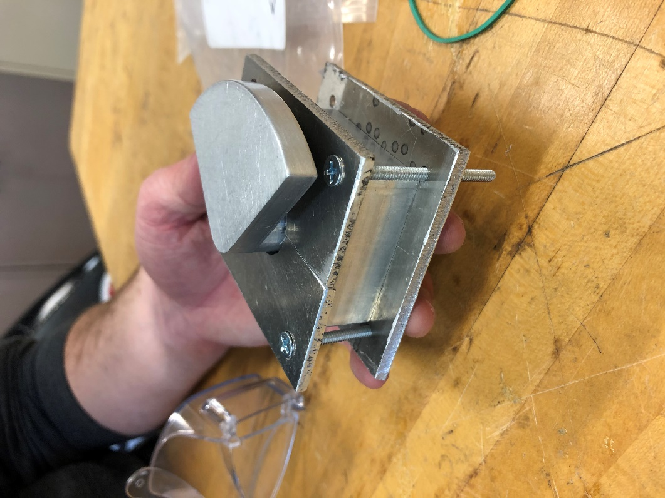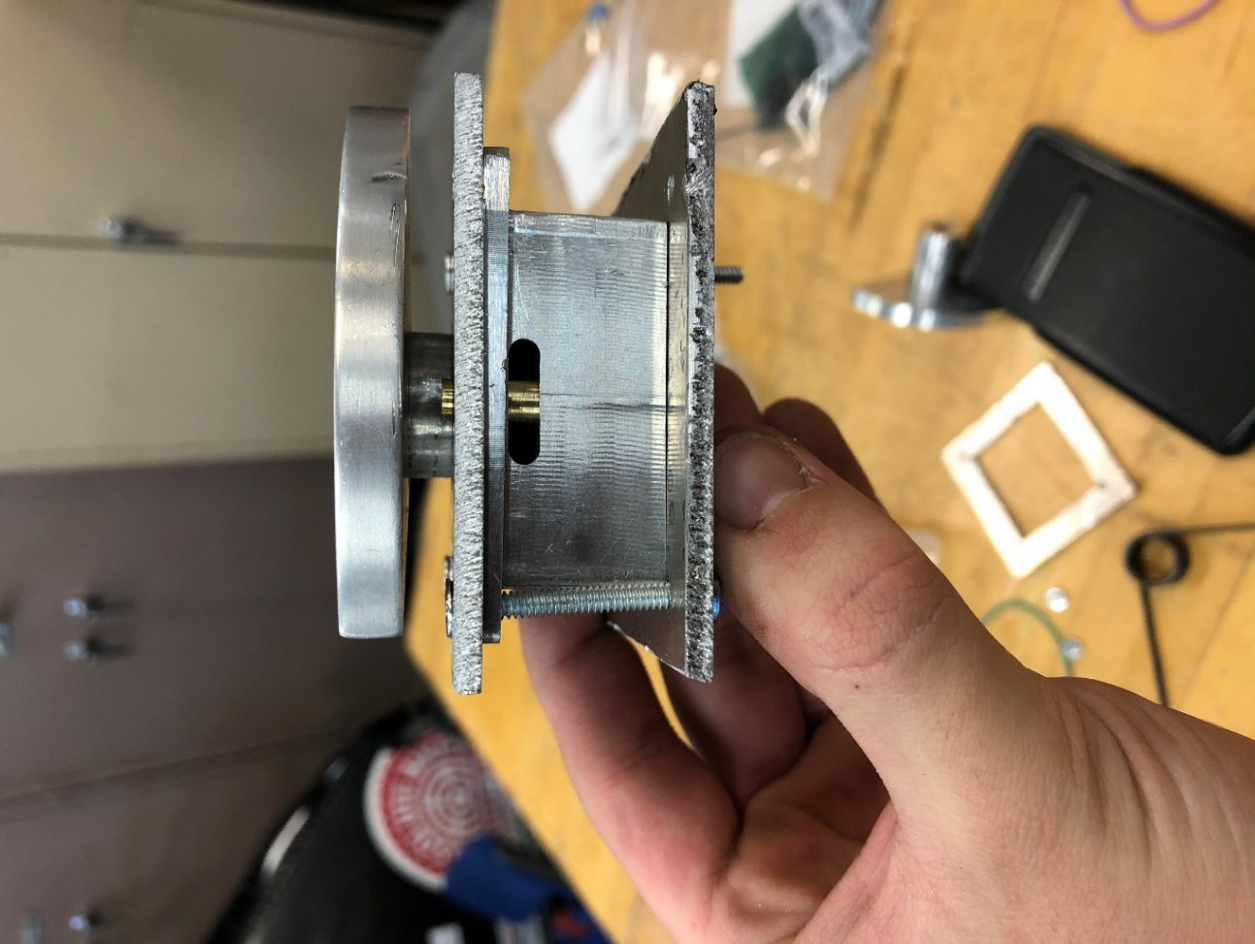

The following are the Action Items each person completed between Hardware Review 2 and the completion of the final product:

Team Member: Timothy Anderson
Action Item | Date Completed | Result/Proof of Completion
Helped assemble device into testing jig and test functionality | 4/6/21 | 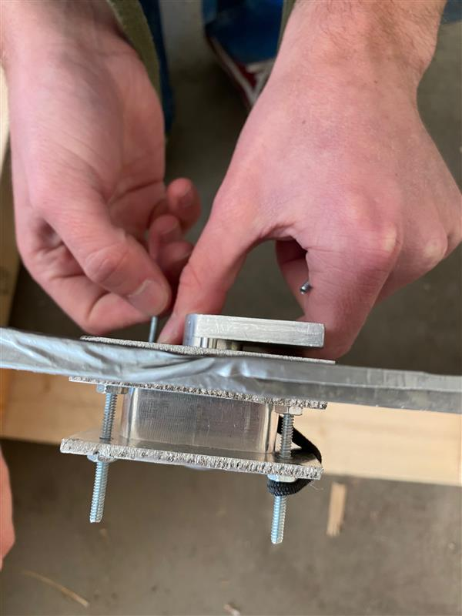
Made adjustments to pin | 4/12/21 | 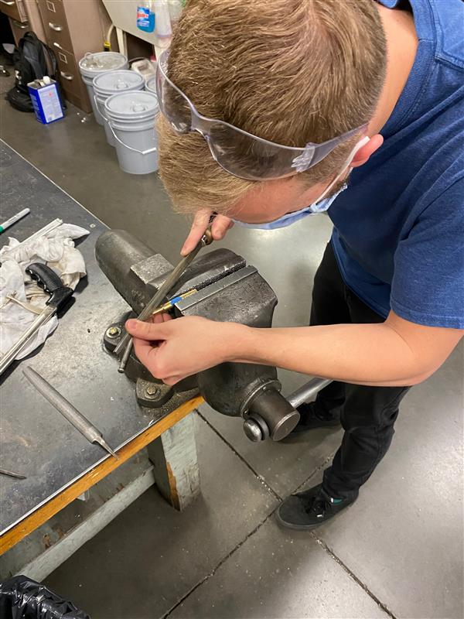
Updated all drawings and bill of materials for final CAD package | 4/21/21 | 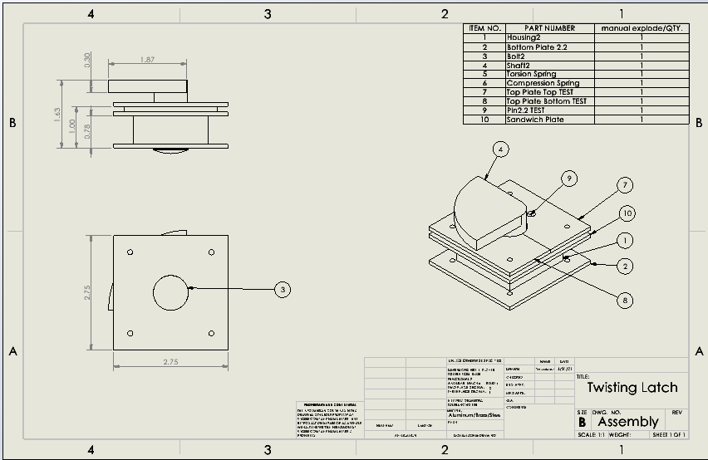

Team Member: Alex Soto
Action Item | Date Completed | Result/Proof of Completion
Finished the Pin in Machine Shop | 4/5/21 | 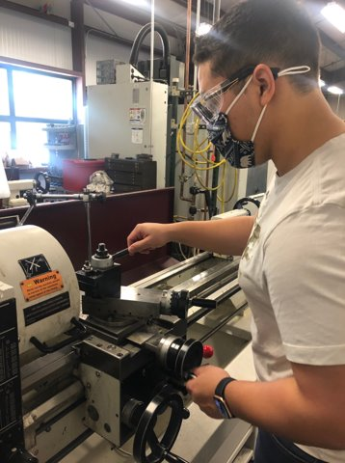
Assembled the device into the Testing Jig at Sam’s House | 4/15/21 | 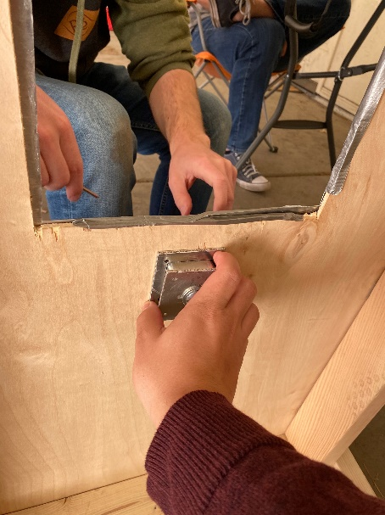
Kept team informed about our client meetings due to the Kaitlyn taking over for Daniel. | 4/23/21 | 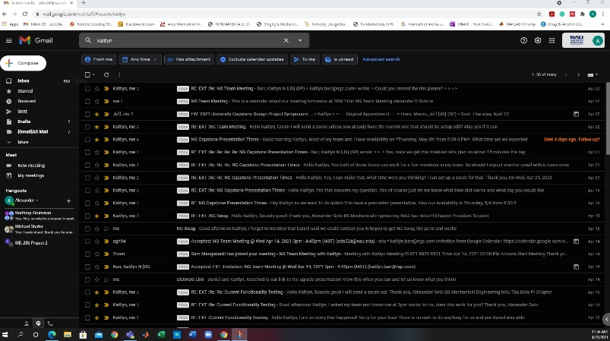

Team Member: Jake West
Action Item | Date Completed | Result/Proof of Completion
Final Assembly in the testing jig | 4/15/21 | 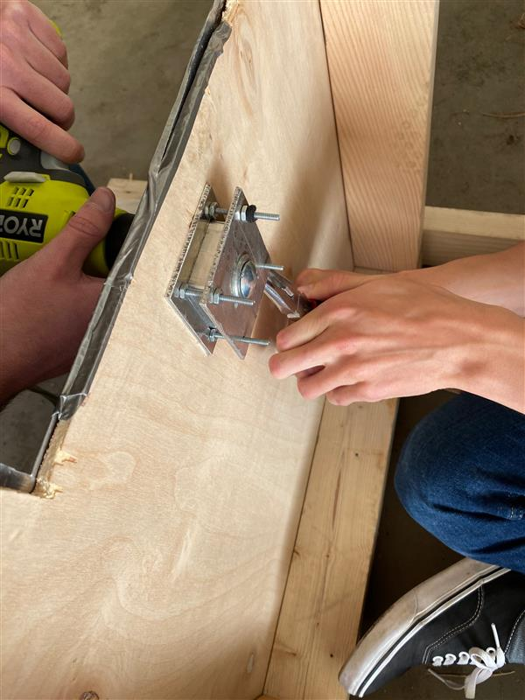
Functional testing with testing jig at Sam’s house | 4/15/21 | 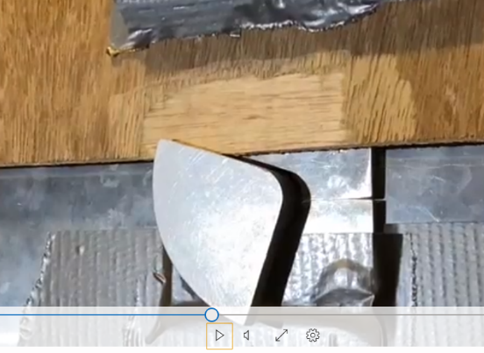
Thermal testing of the shaft and bolt assembly | 4/15/21 | 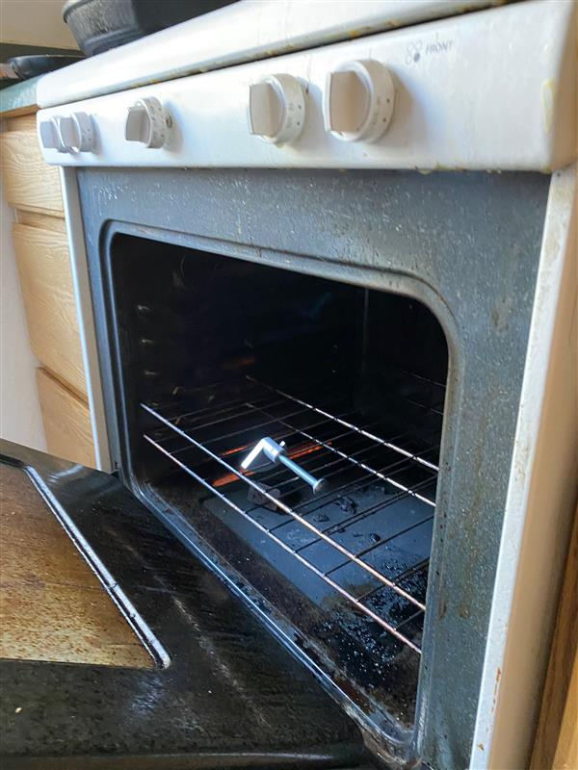

Team Member: Andrea Hernandez
Action Item | Date Completed | Result/Proof of Completion
Continued jig assembly and began installation of product to then complete functional testing. Adjusted housing via fillet additions to make installation easier. | 4/6-15/2021 | 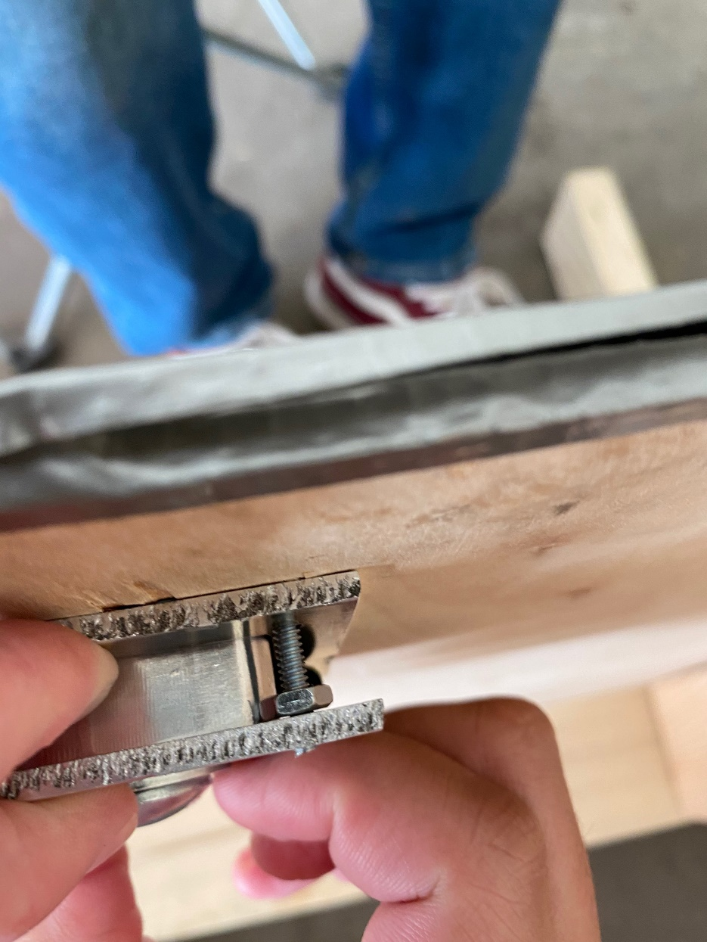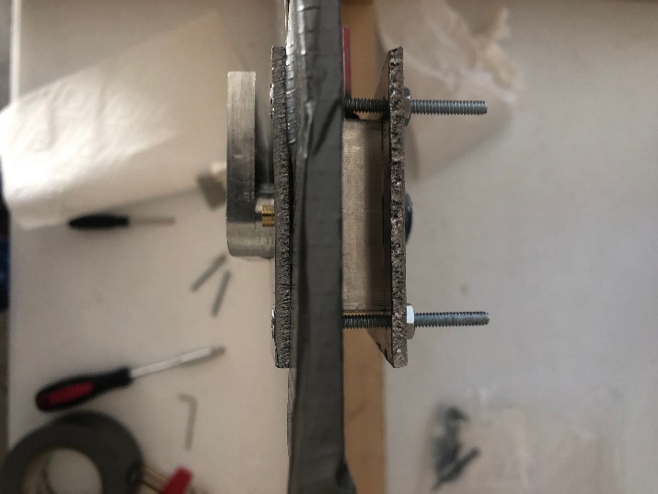
Updated website to show ugrads presentation and other new documents. | 4/14/2021 | 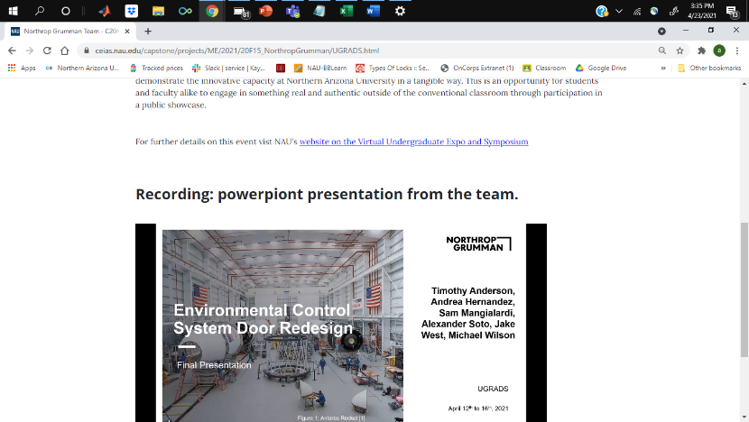
Completed the vibration testing via the options we had. | 4/18/2021 | 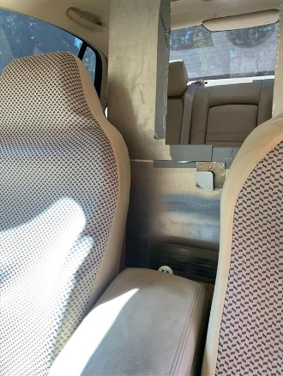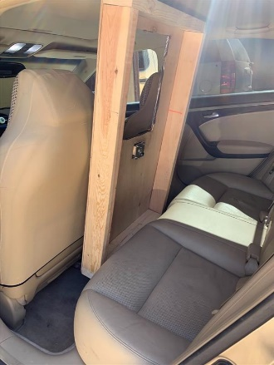

Team Member: Sam Mangialardi
Action Item | Date Completed | Result/Proof of Completion
Final assembly of device inside the test jig with notes taken on installation and uninstallation | 4/15/21 | 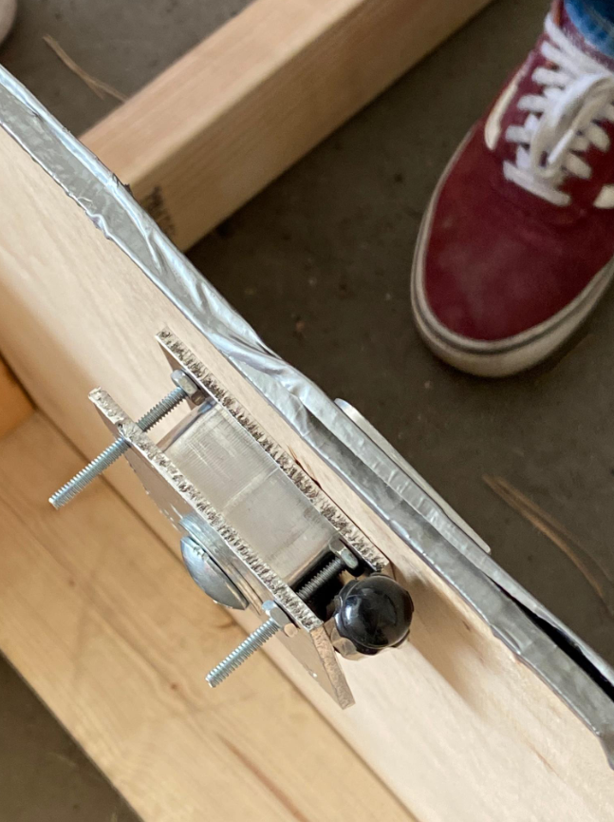
Functional testing of device inside of test jig | 4/15/21 | 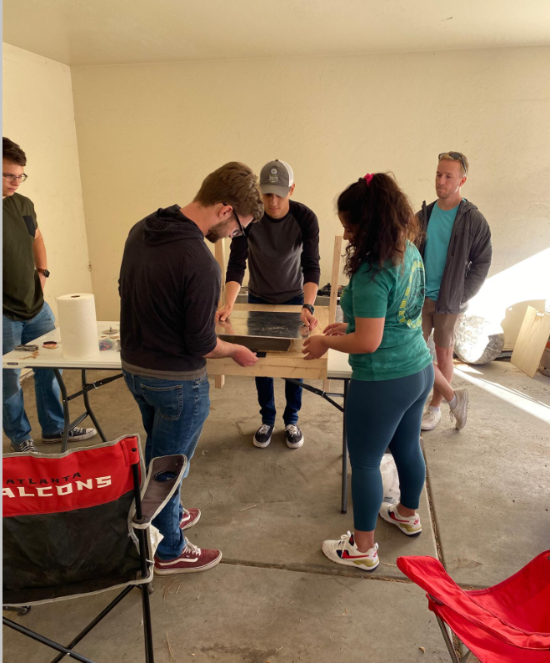
Vibration testing with test jig in the back of my car. Testing done with and without door | 4/18/21 | 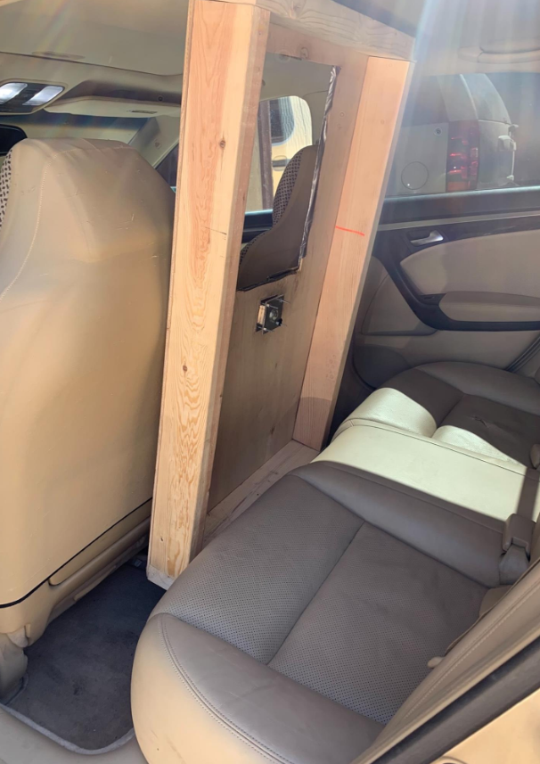
Team Member: Michael Wilson
Action Item | Date Completed | Result/Proof of Completion
Fixing fit of device into fairing for proper installation. | 4/6/21 | 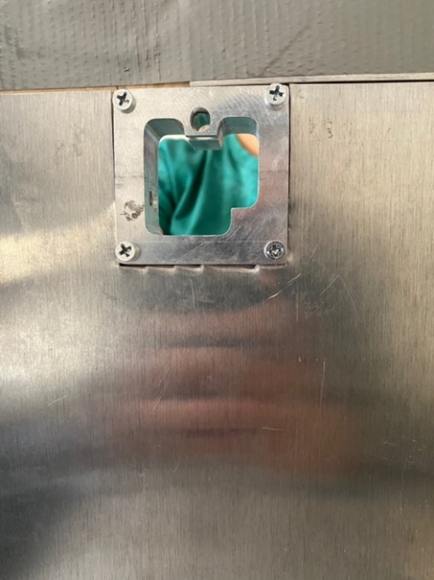
Assisted with final assembly of test jig and functional testing | 4/12/21 | 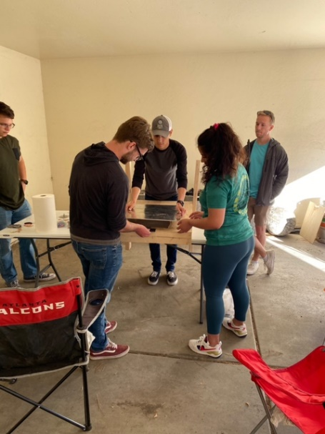
Assisted with installation of device into test jig for vibrations testing. | 4/15/21 | 